The DNA Problem: Regional Variation, Appointment Friction and the Deprivation Myth in NHS Primary Care
Analysing DNA Rates, Appointment Friction & Regional Variation in England
July 2022 – December 2024

Author | David Kamande
Date | 2026
Tools | SQL | Microsoft Excel
Sources | NHS England | DLUHC / ONS (English Indices of Deprivation 2019)
Course | Google Data Analytics Professional Certificate (Coursera)
Purpose | Capstone Portfolio Project — prepared for NHS England hiring panels and data analytics recruiters

1. Executive Summary
This project investigates Did Not Attend (DNA) rates across NHS GP appointment systems in England, covering July 2022 to December 2024. Using publicly available NHS England data, the analysis addresses three research questions — updated mid-project after preliminary findings challenged the assumptions embedded in the original framing — spanning geographic variation, appointment mode effects, and the relationship between deprivation and missed appointments.
The analysis covers 200,000+ appointment records across 96 Sub-ICB locations and 7 NHS regions, processed and analysed using SQL (SQLite) and visualised in Excel. Three key findings emerged, two of which contradict common assumptions in NHS policy commentary.

KEY FINDING 1 — Geographic Variation
DNA rates vary significantly across England, with London (12.15%) and the North West (11.84%) emerging as the primary hotspots. The national average of approximately 4.8% conceals a Sub-ICB spread from 0.00% to 32.84% — a 96-location distribution where roughly half of Sub-ICBs exceed 8%.
This variation is not random. Regional concentration in London and the North West, combined with clustering of high-rate Sub-ICBs within those regions, points to structural and operational factors rather than patient-level behaviour alone.

KEY FINDING 2 — Appointment Mode and Friction
Face-to-face appointments carry the highest DNA rate (10.65%) — more than 5 times higher than video/online appointments (1.94%) and nearly twice the telephone rate (5.77%). The post-COVID shift toward remote and digital consultations has not increased missed appointments; it has reduced them.
This pattern is consistent across all seven NHS regions, suggesting a systemic mechanism rather than a regional anomaly. The most plausible explanation is cancellation friction: telephone and digital appointments are easier to quietly ignore, but face-to-face bookings carry a stronger psychological commitment — making a person more likely to cancel rather than simply not attend. Video/online appointments have grown nearly 10-fold since July 2022 (0.58% to 5.54% of all appointments), representing a significant and underutilised lever for reducing DNAs further.

KEY FINDING 3 — Deprivation and Access Inequality
Contrary to the assumption that underpins much NHS access inequality literature, the least deprived areas (IMD bands 9–10) show the highest average DNA rate in this dataset (7.40%), compared to 6.12% in the most deprived areas analysed (bands 5–6).
This finding does not mean deprivation is irrelevant to healthcare access; it means deprivation alone is not a reliable predictor of GP DNA rates at Sub-ICB level. The wide range of DNA rates within each deprivation band, combined with the counterintuitive direction of the relationship, strongly suggests that confounding factors — particularly appointment mode mix and urban density — dominate the signal. Commissioners should not assume that deprived areas are the primary source of the DNA problem.

The analysis concludes with three evidence-based recommendations focused on accelerating the shift to lower-friction appointment modes, targeting resources at the highest-rate regions rather than the most deprived, and commissioning a more granular deprivation analysis that controls for mode mix and urban classification.

2. Background & Problem Statement
2.1 The NHS Primary Care Challenge
GP appointment DNA rates represent one of the most persistent and costly inefficiencies in NHS primary care. Each missed appointment occupies a slot that could have served another patient, contributing to the backlog of unmet demand that has intensified since the COVID-19 pandemic. NHS England estimates the annual cost of missed GP appointments at over £1 billion, with DNA rates consistently running above 5% of all booked appointments.
The pandemic triggered a fundamental shift in how GP appointments are delivered — from a predominantly face-to-face model to a mixed model incorporating telephone, video, and online channels. The NHS Long Term Plan explicitly encouraged this shift as part of its primary care access strategy. However, the effect of this mode shift on attendance behaviour has been underexplored in published primary care analytics. A widely held assumption — that remote appointments are harder to attend, and therefore associated with higher DNA rates — has rarely been tested against systematic data.
This project addresses that gap, using NHS England's own published datasets to examine whether the post-pandemic mode shift has helped or harmed attendance rates, and where the greatest opportunities for DNA reduction lie.
2.2 Research Questions
This analysis is structured around three research questions. The original questions were refined mid-project after preliminary data analysis revealed that the initial framing contained embedded assumptions that the data contradicted. The revised questions are more diagnostic and more honest to what the evidence actually supports.

 | Original Question | Revised Question
Q1 | Where in England are DNA rates highest, and is there meaningful regional variation at Sub-ICB level? | Where are DNA rates highest, and what structural factors explain the concentration in specific regions?
Q2 | Does appointment mode (face-to-face, telephone, home visit) influence the rate at which patients do not attend? | Does reducing appointment friction through remote and digital modes lower DNA rates, and how much of the regional variation can be explained by mode mix differences?
Q3 | Is there a relationship between area-level deprivation and DNA rates, suggesting an access inequality dimension? | Is deprivation a reliable predictor of DNA rates, or do other factors — such as appointment mode mix and urban density — confound the relationship?

2.3 Relevance to NHS England Priorities
These questions align directly with NHS England's primary care recovery plan, which identifies DNA reduction, equitable access, and digital transformation as priority workstreams. The analysis uses the same datasets that NHS England's own primary care analytics team publishes, making the findings directly translatable to operational decision-making at ICB and Sub-ICB level.

3. Data & Methodology
3.1 Data Sources
Dataset | Source | Coverage | Used For
PCN Appointments (Granular Sub-ICB) | NHS England | Apr 2023 – Dec 2024 154,002 rows | Q1 Regional DNA rates Q3 Deprivation analysis
Appointments National Overview | NHS England | Jul 2022 – Dec 2024 49,703 rows | Q2 National trend Mode mix over time
English Indices of Deprivation 2019 | DLUHC / ONS | All LSOAs in England ~32,000 rows | Q3 Deprivation join

3.2 Tools
- SQL (SQLite via DB Browser for SQLite) — data import, cleaning, and all analytical queries
- Microsoft Excel — export processing, pivot tables, and dashboard charts

3.3 Data Cleaning Decisions
All raw data was imported into separate staging tables before cleaning. A structured cleaning process was applied, with every decision documented for auditability.

Cleaning Decision | Rationale | Records Affected
Excluded 'Booked' status rows | Future appointments with no attendance outcome. Including in DNA denominators would understate the true rate. | ~52,013 rows
Excluded 'UNMAPPED' region rows | No geographic identity. Cannot contribute to regional or deprivation analysis. | ~2,892 rows
Normalised 'DNA' to 'Did Not Attend' | Standardised terminology consistent with NHS reporting conventions throughout the project. | All status fields
Standardised date format to YYYY-MM-DD | Raw files used two different formats (APR2023 and 01APR2023). Standardised for correct chronological sorting. | All date fields
Excluded 'Unknown' status from denominators | Unknown outcome rows are retained but excluded from DNA rate calculations to avoid understating rates. | Applied in all rate queries
Retained IMD rows with invalid decile as NULL | Out-of-range decile values indicate data entry error. Set to NULL to preserve the row for score-based joins. | Minimal

3.4 Analytical Approach
SQL aggregate queries were used to calculate DNA rates as the proportion of appointments with status 'Did Not Attend' against total attended-or-DNA appointments, expressed as a percentage. Results were exported as CSV and visualised in Excel using line charts, bar charts, stacked area charts, and clustered bar charts. The deprivation analysis joins Sub-ICB level DNA rates to Local Authority level IMD scores via a text-matching approximation, documented as a limitation in Section 5.
DNA Rate formula applied throughout: DNA Rate (%) = (DNA Count / (DNA Count + Attended Count)) × 100. Booked and Unknown statuses are excluded from both the numerator and denominator.

4. Key Findings
4.1 Q1 — Regional DNA Rates and Structural Concentration
Analysis of the PCN granular dataset reveals significant variation in DNA rates across all seven NHS regions and 96 Sub-ICB locations in England. The national average of approximately 4.8% is stable across the 30-month period, but this masks a 2.7× gap between the highest (London, 12.15%) and lowest (South West, 4.51%) regions.

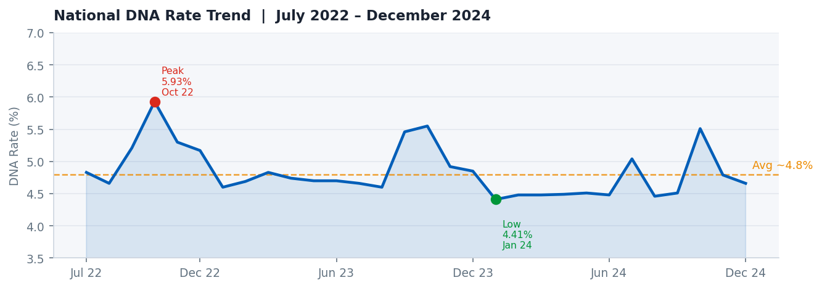
Figure 1 — National DNA rate trend, July 2022 – December 2024. Rates have remained broadly stable (4.41%–5.93%) with no persistent upward trajectory. Oct 2022 and Oct 2024 show seasonal spikes.
The national trend line is reassuring at a macro level — there is no systemic national crisis. However, thinking of it as analogous to a national average temperature: a stable national figure can coexist with a dangerous heatwave in one city and sub-zero temperatures in another. The regional picture reveals exactly this pattern.

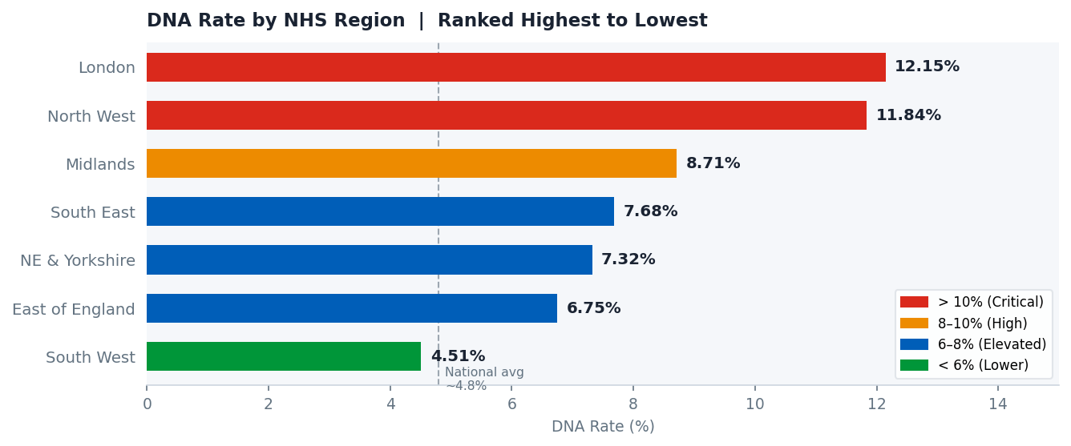
Figure 2 — DNA rate by NHS region. London and the North West are in a different tier from the other five regions, both exceeding 11%.
- London: 12.15% — 513,023 DNAs from 4,223,020 appointments. The highest rate by a wide margin and 2.7× above South West.
- North West: 11.84% — 182,335 DNAs from 1,540,415 appointments. Close behind London and host to five of the top ten worst Sub-ICBs nationally.
- Midlands: 8.71% — substantially above the national average, with significant internal variation.
- South West: 4.51% — the best performing region, notable given it contains the nationally outlying Sub-ICB in Bristol (21.84%).

Sub-ICB Variation
At Sub-ICB level, the spread is extreme. The following league table shows the ten highest and ten lowest DNA rate Sub-ICBs nationally, drawn from the full 96-location dataset.

Sub-ICB | Region | DNA % | Appointments
NHS Staffordshire & Stoke-on-Trent — 05Q | Midlands | 32.84% | 974 / 2,966
NHS Bristol, N.Somerset & S.Gloucestershire | South West | 21.84% | 45 / 206
NHS Hertfordshire & West Essex — 06N | East of England | 21.49% | 14,422 / 67,107
NHS Bucks, Oxon & Berkshire West — 14Y | South East | 17.35% | 656 / 3,780
NHS Cheshire & Merseyside — 99A | North West | 16.93% | 277 / 1,636
NHS Lancashire & South Cumbria — 02G | North West | 15.54% | 8,031 / 51,693
NHS Greater Manchester — 14L | North West | 14.88% | 27,365 / 183,885
NHS Staffordshire & Stoke-on-Trent — 05W | Midlands | 14.72% | 8,682 / 58,972
NHS Lancashire & South Cumbria — 01A | North West | 14.67% | 20,253 / 138,094
NHS Coventry & Warwickshire | Midlands | 14.59% | 41,456 / 284,223
Table 1 — Top 10 highest DNA rate Sub-ICBs. Note that 05Q (32.84%) is a significant outlier driven by very low appointment volumes (2,966); its rate warrants investigation but should be interpreted cautiously.

Sub-ICB | Region | DNA % | Appointments
NHS Humber & North Yorkshire — 03H | NE & Yorkshire | 0.00% | 0 / 12
NHS Suffolk & North East Essex — 07K | East of England | 0.00% | 0 / 275
NHS Suffolk & North East Essex — 06L | East of England | 2.21% | 839 / 37,883
NHS Mid & South Essex — 99E | East of England | 2.59% | 4,175 / 161,228
NHS Mid & South Essex — 99F | East of England | 3.18% | 2,707 / 85,125
NHS West Yorkshire — 03R | NE & Yorkshire | 3.23% | 2,353 / 72,920
NHS Cornwall & Isles of Scilly | South West | 3.27% | 89 / 2,718
NHS Sussex — 97R | South East | 3.30% | 2,032 / 61,635
NHS Dorset | South West | 3.35% | 6,538 / 194,928
NHS Hertfordshire & West Essex — 07H | East of England | 3.48% | 1,640 / 47,134
Table 2 — Bottom 10 lowest DNA rate Sub-ICBs. East of England features prominently among best performers.

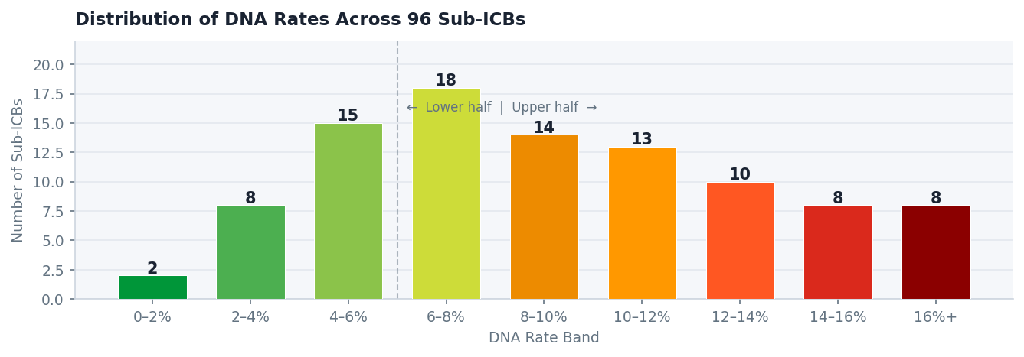
Figure 3 — Distribution of DNA rates across 96 Sub-ICBs. Roughly one third are below 6%, one third between 6–10%, and one third above 10%. The distribution is right-skewed, pulled upward by a tail of high-rate Sub-ICBs concentrated in London and the North West.

4.2 Q2 — Appointment Friction and DNA Rates
The single strongest finding in this analysis is the relationship between appointment mode and DNA rate. Face-to-face appointments have a DNA rate of 10.65% — 1.8× higher than telephone (5.77%), 4× higher than home visits (2.68%), and 5.5× higher than video/online appointments (1.94%).
This is not a marginal difference. It holds consistently across all seven regions and is present in the full 30-month dataset. The direction of the finding also contradicts a common assumption: that remote appointments are harder to attend because they require patients to manage technology or find a private space. The data suggests the opposite.

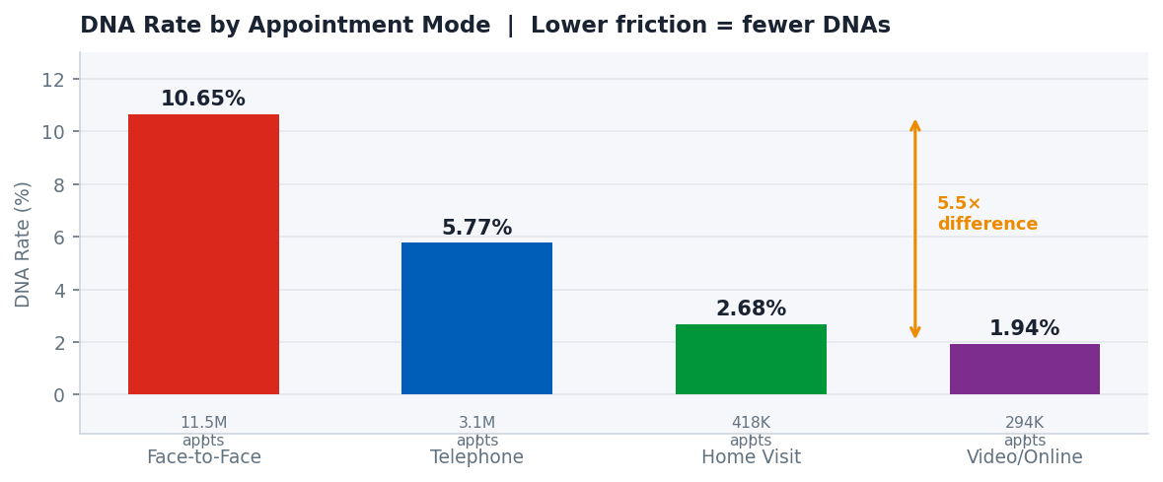
Figure 4 — DNA rate by appointment mode. Face-to-face is over 5× higher than video/online. Note the volume beneath each bar: face-to-face accounts for 11.5M appointments in this dataset vs 294K for video/online.
The Cancellation Friction Mechanism
The most coherent explanation is not that face-to-face appointments are harder to get to (the 'travel cost' hypothesis), but that they are harder to silently abandon. A face-to-face booking carries an implicit social contract — missing it requires a conscious choice to leave a slot empty, whereas a telephone or video appointment can be quietly ignored without the same psychological barrier.
This mirrors a well-documented behavioural pattern in service industries: people are more likely to abandon an online shopping cart than walk out of a physical shop mid-purchase. The 'friction' that matters is at the exit, not the entrance.
The travel cost hypothesis — that patients in less affluent areas cannot afford bus fares or fuel — is also challenged by the deprivation data (Section 4.3), which shows that the least deprived areas have higher DNA rates. If transport cost were the primary driver, the pattern would be inverted.

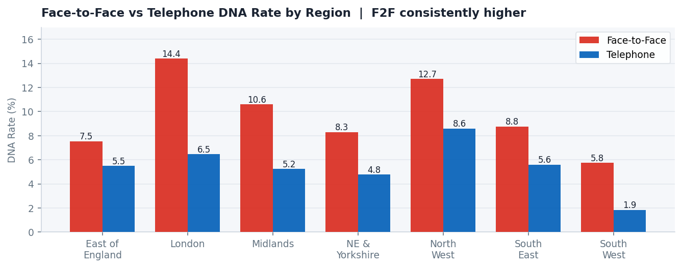
Figure 5 — Face-to-face vs telephone DNA rate by region. F2F consistently exceeds telephone in every region. Note the North West's telephone DNA rate (8.60%) — higher than the face-to-face rate in South West (5.76%) — which shows that regional factors compound the mode effect.
Mode Mix Shift and the Digital Opportunity
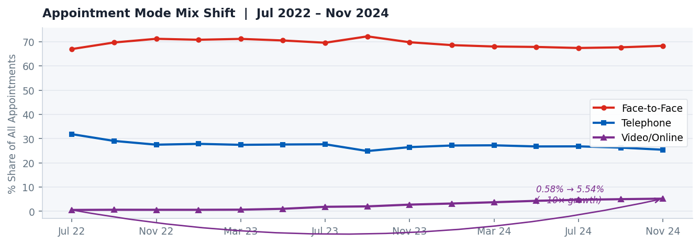
Figure 6 — Appointment mode mix over time. Face-to-face has remained broadly stable around 67–72%. Telephone has gradually declined. Video/online has grown from 0.58% to 5.23% of all appointments.

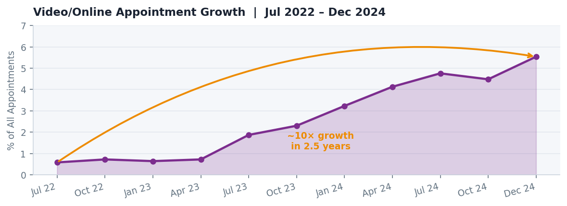
Figure 7 — Video/online appointment share, July 2022 – December 2024. Growth from 0.58% to 5.54% represents a near 10× increase. The trajectory is consistent and accelerating.

- Video/online appointments grew from 0.58% of all appointments (Jul 2022) to 5.54% (Dec 2024) — a near 10× increase in 2.5 years.
- Despite this growth, video/online still accounts for less than 6% of all appointments. Face-to-face (at ~67%) remains dominant.
- If video/online share doubled from 5.54% to 11%, and face-to-face fell commensurately, the blended national DNA rate would drop by an estimated 0.3–0.5 percentage points — equivalent to tens of thousands of avoided missed appointments annually.

4.3 Q3 — Deprivation as a Predictor of DNA Rates
The original framing of this question assumed a positive relationship between deprivation and DNA rates — consistent with the existing literature on healthcare access barriers. The data does not support this assumption at Sub-ICB level.

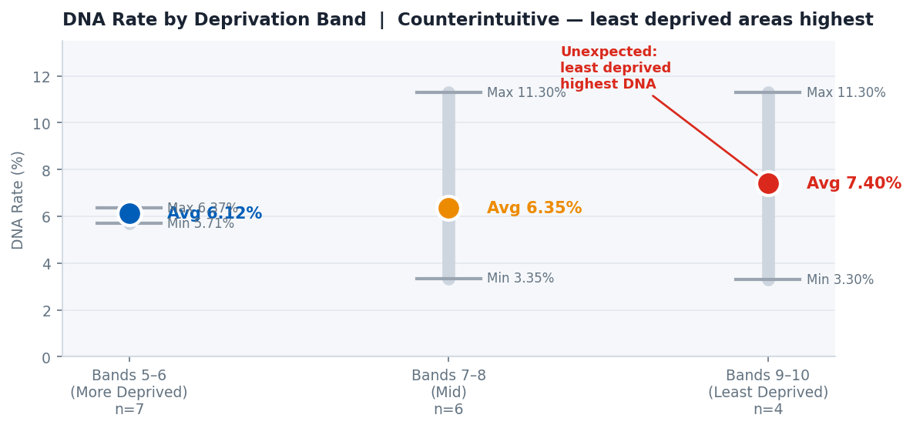
Figure 8 — DNA rate by deprivation band. Dots represent average DNA rates; vertical bars show the min-to-max range within each band. The least deprived areas have the highest average, but all bands show wide internal ranges.
Deprivation Band | Areas (n) | Avg DNA % | Min DNA % | Max DNA %
Bands 5–6 (More Deprived) | 7 | 6.12% | 5.71% | 6.37%
Bands 7–8 (Mid) | 6 | 6.35% | 3.35% | 11.30%
Bands 9–10 (Least Deprived) | 4 | 7.40% | 3.30% | 11.30%
Table 3 — DNA rate by IMD deprivation band. Counterintuitively, the least deprived band has the highest average DNA rate. The wide min-max ranges within each band indicate limited predictive power.

Three observations temper a strong conclusion here. First, the sample sizes per band are small (4–7 areas), making averages sensitive to individual outliers. Second, the min-to-max ranges are very wide — particularly in bands 7–8 and 9–10 (both ranging from ~3% to 11%) — suggesting that the average is not representative of the typical area within each band. Third, the deprivation join is a text-based approximation (see Limitations, Section 5), introducing imprecision.
What the data does clearly show is that deprivation cannot be used as a reliable proxy for identifying high-DNA Sub-ICBs. The highest-DNA Sub-ICBs (London, North West) are not the most deprived, and some of the best performers are in areas of mixed deprivation. Commissioners should treat this as a prompt for more granular investigation — controlling for mode mix, urban/rural classification, and practice-level variation — rather than as confirmation of an access inequality narrative.

5. Limitations
- The Sub-ICB level data covers appointments recorded through Primary Care Network hub systems rather than all GP practice appointment systems. The geographic analysis may not represent all GP appointments in each Sub-ICB area. The national trend analysis uses the broader GP practice-level National Overview dataset (30 months, July 2022 – December 2024), which provides greater coverage.PCN vs GP Practice Systems:
- The deprivation analysis joins Sub-ICB DNA rates to Local Authority level IMD scores using a text-based name match. This is an approximation — Sub-ICB and Local Authority boundaries do not map perfectly. A more precise analysis would use an NHS-published LSOA-to-Sub-ICB lookup table.Geographic Join Approximation:
- The deprivation data used is from the 2019 release. Socioeconomic conditions have shifted since then. A 2025 IMD release exists but is not yet consistently mapped to the Sub-ICB geography used here.IMD 2019 Currency:
- All relationships identified are observational. This analysis does not control for confounding variables such as practice size, patient demographics, clinical speciality mix, or local reminder system quality. The mode-DNA relationship in particular, while strong and consistent, would benefit from a controlled study design before informing major commissioning decisions.Causation vs Correlation:
- Two Sub-ICBs with 0.00% DNA rates have very low appointment volumes (12 and 275 appointments respectively), making their rates statistically unreliable. Similarly, the 32.84% rate in Staffordshire & Stoke-on-Trent 05Q is derived from only 2,966 appointments.Outlier Sub-ICBs:

6. Recommendations
6.1 Accelerate the Shift to Lower-Friction Appointment Modes
The most actionable finding in this analysis is the 5.5× gap in DNA rates between face-to-face (10.65%) and video/online appointments (1.94%). Every percentage point shift in mode mix from face-to-face toward telephone or digital has a directly measurable impact on DNA rates.
- NHS commissioners should set explicit targets for video/online appointment share at Sub-ICB level, building on the existing growth trajectory (0.58% to 5.54% since 2022).
- GP practices in high-DNA regions should be supported to expand telephone and video triage capacity, with particular focus on converting routine follow-up and review appointments to remote modes where clinically appropriate.
- Patient-facing communications should actively normalise digital and telephone appointments, addressing any perception that face-to-face is a higher quality of care.
Note: This recommendation deliberately does not suggest moving patients 'away from face-to-face' as a catch-all. Clinical appropriateness must remain the primary allocation criterion. The recommendation is to expand the pathway for appointments that are clinically suitable for remote delivery.
6.2 Target London and North West for Regional DNA Reduction Programmes
London (12.15%) and North West (11.84%) together account for a disproportionate share of national DNAs. Within the North West, five of the ten worst Sub-ICBs are geographically concentrated — Greater Manchester, Lancashire, and Cheshire clusters — suggesting systemic regional factors rather than isolated GP-level issues.
- NHS England should commission a dedicated regional review in London and the North West, examining mode mix, practice-level reminder systems, appointment booking lead times, and demographic factors including transient and non-English speaking populations.
- Sub-ICBs in the top decile nationally should be required to produce DNA reduction plans with measurable targets, reviewed at quarterly ICB performance cycles.
- Best-practice sharing between the lowest-performing and highest-performing Sub-ICBs should be facilitated — particularly learning from the East of England (6.75% average, with several Sub-ICBs below 3.5%).
6.3 Commission a Controlled Deprivation Analysis Before Targeting Deprived Areas
The finding that deprivation does not reliably predict DNA rates at Sub-ICB level should be treated as a prompt to investigate further rather than to abandon the access inequality hypothesis entirely.
- NHS England should commission a more granular deprivation analysis that controls for appointment mode mix, urban/rural classification, and practice size — the confounders most likely to be driving the counterintuitive pattern observed here.
- DNA rate disaggregated by IMD decile should be added to NHS England's routine primary care performance monitoring framework, but only once the mode-mix confounder is adequately controlled. Publishing raw DNA-by-deprivation data without this adjustment risks misdirecting commissioner attention toward deprived areas that are not the primary source of the problem.
- The current framing of DNA reduction as an 'access inequality' issue should be tested more rigorously. The data here suggests it may be better characterised as a 'friction and commitment' issue, with implications for how interventions are designed.

7. Portfolio Notes for Reviewers
7.1 Skills Demonstrated
Skill Area | Evidence in This Project
Data Collection | Identified, evaluated, and downloaded four public NHS and ONS datasets independently
Data Cleaning (SQL) | Applied 6 documented cleaning transformations with full audit trail; handled nulls, casing, date formats, and invalid values
Exploratory Analysis | Ran systematic sense checks before and after cleaning; identified structural issues including the 'Booked' status problem and UNMAPPED rows
Descriptive Analysis | Calculated DNA rates, mode share, and deprivation-band averages using SQL aggregate functions including window functions (OVER / PARTITION BY)
Data Joining | Joined across three datasets with different geographic granularities; documented join limitations transparently
Data Visualisation | Designed chart outputs across multiple chart types; embedded in formal case study document
Critical Thinking | Revised research questions mid-project after data challenged original assumptions; distinguished correlation from causation; documented methodology decisions
Analytical Communication | Translated counterintuitive findings into clear, evidence-based recommendations directed at NHS England commissioners

8. Appendix — Data Sources & Access Links
Dataset | Publisher | Access URL
Appointments in General Practice (National Overview & PCN Granular) | NHS England | digital.nhs.uk/data-and-information/publications/statistical/appointments-in-general-practice
English Indices of Deprivation 2019 (File 7 — full combined CSV) | DLUHC / ONS | gov.uk/government/statistics/english-indices-of-deprivation-2019
GP Patient Survey 2024 (ICB-level results) | NHS England | gp-patient.co.uk/reporting-2024

All datasets are publicly available, free to access, and published under the Open Government Licence v3.0. No patient-identifiable data was used at any stage of this project.

